Standard Operating Procedure
Diet Analysis

Introduction
Fish diet composition can be quantified in several ways. The most common methods are frequency of occurrence, percent composition by number, and percent composition by weight (Bowen 1996). Percent composition by weight may be expressed by dry weight or wet weight, and by volume by measuring water displacement. In the Fisheries Ecology Laboratory we will most often express diet composition as mean percent of wet weight (live mass) per predator fish. This method alleviates the biases of the other methods for two main reasons; it is based on prey mass before it was subjected to digestion so differential digestion rates of both predator and prey are not as important and it does not over represent common diet items that may not be as important energetically as the case may be when using frequency of occurrence.

Stomach samples are very expensive and labor intensive to collect and they are irreplaceable so be careful and pay attention to the details of this protocol.

Purpose: to ensure that consistent and appropriate methods are used in the analysis of fish stomach contents.

Procedures (See overview, Figure 1)

Sample collection
Samples should be preserved in 10% formalin or 70% ethanol, or frozen; this should occur as soon as possible after collection to prevent digestion after the fish has died. Formalin is the preferred method because it does the best job of preserving diet items and makes identifying remains much easier.

Complete labeling of field samples is essential. Always use sample numbers according to the standardized format; see Sample Check-in #5 below. Be sure to put the sample number on every label, bag and datasheet (make sure they are all consistent). Labels should be on bond paper and you need to use pencil.

Sample Check-in
- Samples should be catalogued upon arrival at the lab. This includes putting samples in an appropriately labeled bin, making sure the field datasheets are filed into the diet binder, and making sure that the new samples are entered into the appropriate database.
- Stomach samples are normally stored on the north wall of the lab; samples should be stored in bins with tops to retain fumes.
- Enter all data from the field sheets into the diet database. This includes sample code, sample date, river mile (if applicable), species, total length (mm), and weight (g).
- After all of the information has been entered, mark the field sheet as “entered into database” and place the field sheets in the diet binder according to sampling date.
- Like most samples in the lab, diet samples are identified by a unique code that reflects the location it was sampled as well as the date. Here’s an example: B-FB0722040012 means the fish was collected at the Fruita bridge backwater on July 22, 2004 and it was the 12th fish processed. This entire code must be transcribed from the field datasheets to the database exactly.

Sample Handling
- Use a 400 μ strainer (located on rack above the sink) to separate the stomach/contents from the preservative. Dispose of all waste preservatives according to CSU Environmental Health Services procedures. Do not flush preservative down the drain.
- Thoroughly rinse the material in the strainer with tap water to remove residues of the preservative.
- Be careful to retain all material from the sieving process since food remains often come out of the stomach during handling. Even small particles may provide clues to identify remains.
- Rinse remains into the sample whirl-pak and fill the whirl-pak with tap water; do not seal the whirl-pak. Place the whirl-paks in a container to prevent them from being spilled and leave them in the sink under the fume hood.
- Allow samples to soak in water for about 2 – 3 days. Avoid leaving stomachs in water any longer because they may start to decompose. Change the water at least once per day.
- Remember to wear gloves when handling the samples to avoid contact with preservative.

Stomach Dissection
- Before opening any stomachs be sure that you have enough time to finish what you have started. It is difficult to go back and identify remains after they have been taken out of the context of the stomach and the other remains.
- The sample should give off little or no odor of the preservative- if formalin odor is strong then rinse it thoroughly with tap water within a strainer (Figure 1).
- Before you start to analyze the sample be sure to fill out the top portion of the datasheet completely. Record the sample number, tag number, and length/weight sections also.
- Place the stomach and any remnants into a Petri dish and place under a dissecting microscope.
- Add some 70% ethanol to the original whirl-pak. As you analyze remains you will be putting them into back into the whirl-pak with ethanol to avoid double counting. We try to reuse the original whirl-pak because it is already marked appropriately so it saves time and lab resources.
- You are now ready to dissect the stomach. Familiarize yourself with the shape of the stomach and imagine a line that runs down the longitudinal axis of the stomach. Begin cutting along this line with a sharp scalpel.
- Cut very lightly at first to score the stomach and establish your cut. Cut with increasing pressure/depth as necessary but don’t overdo it. Cutting too deep could damage the remains and make them more difficult to identify.
- After you have cut all the way around the stomach and through the wall, pry the two halves apart but be sure to leave the contents intact.
- Rinse the contents out of the stomach into the Petri dish with distilled water.
- Set the empty stomach and associated wastes into a container to dry. After these are dried, discard into the waste container labeled “FISH WASTE” outside the lab.

Identification and Enumeration of Remains
- Gently tease contents apart and assess whether they can be completely counted or need to be subsampled (all large prey are counted completely).
- Contents to be subsampled are diluted to a known volume (usually 100 mL), gently stirred, and a 10% subsample is removed.
- Contents are then identified to the lowest possible taxon, measured and enumerated with aid of a gridded Petri dish or Ward counting wheel under a dissecting microscope with an ocular micrometer.
- Since remains are almost never complete, identifying them to the species or even genus level can be difficult. Desired taxonomic resolution is as follows. Fish: Species; Insects: Order or Family; Crustacea: Order or Family; Other: Order.
- Don’t rush, spend the time necessary to feel confident about your identifications. There are many references if you get stuck.
- There are some “tricks” to make identification easier:
  - For fish remains, first look for structures such as otoliths, or hardened fin rays or spines, as these characteristics can often narrow the choices down to a single family instantly.
  - For insect remains, familiarize yourself with the major characteristics among the common order of aquatic insects (e.g. Plecoptera, Ephemeroptera, Trichoptera, Hemiptera, and Diptera). There are very straightforward differences among these orders that can quickly narrow down the possibilities.
  - There is only one crayfish genus known to inhabit Colorado waters, Orconectes, so all crayfish remains are assumed to be this genus.

Prey Measurements
- Measure up to 10 individuals per taxon per fish, to the nearest 0.1 mm.
- For standard measurement locations on all organisms, refer to the Diet SOP under the “measurement protocol” tab.
- The following codes should be used to denote the type of measurement done: BDL = body lengths (plankton); BDD= Body Depth; TTL = total length; BBL = complete backbone length; PAR = partial backbone length; HCW = Head Capsule Width; CPL = Carapace Length; IOW= Interocular Width; CHW-1: First Chela Width.
- When measuring fish backbone lengths it is important to distinguish between complete and partial backbones. If you have most of a backbone and can make an educated guess as to what the complete backbone length would be then do so.
- Immediately separate out any fish remains into another Petri dish with distilled water. Since identification usually requires picking the remains apart, always perform measurements first. Be very careful and pay attention because often times, what looks like one fish carcass, may actually be two or three carcasses. After you have recorded all pertinent measurements, you may identify the fish remains.
- While crayfish do not need to be keyed out, they must be left intact until the carapace length is taken. Often times partially digested crayfish have very fragile exoskeletons so handle them carefully to ensure accurate measurements.
- Before you remove the fish and crayfish remains from your Petri dishes, be sure to rinse them off thoroughly as many times the remains of insects will be stuck in the nooks and crannies.
- Pick out all insect remains that you can see and place them in another Petri dish with distilled water.
- After you have measured everything examine each Petri dish under the scope again. Head capsules of smaller insects are initially missed, or you may find a piece of tissue that contains an important clue that you had overlooked before.

Data Entry
- Consistency in codes and abbreviations is essential. Always refer to the tables showing the standardized species codes, and other codes used in diet work.
- Data are entered in Access databases or Excel spreadsheets. Be careful not to create more than one database or spreadsheet for the same set of data!
- Be sure to back up data in a second location.

Health and Safety Considerations
Samples are usually preserved in 10% buffered formalin or 70% ethanol. Both are potentially hazardous. Wear gloves and eye protection when handling samples and work under the fume hood whenever possible. Use the fume hood duct when examining samples under the compound microscope; a small fan can be used to blow fumes away from the investigator when using dissecting scopes. Ethanol is extremely flammable-keep away from heat, sparks or flames. Dispose of all waste preservatives according to CSU Environmental Health Services procedures.

References
Allan, J.D. 1984. The size composition of invertebrate drift in a rocky mountain stream. Oikos 43. 68-76.

Anderson, R.O. and R.M. Neumann. 1996. Length, weight, and associated structural indices. Pages 447 – 482 in Murphy, B.R. and D.W. Willis, eds. Fisheries Techniques, second edition. American Fisheries Society, Bethesda, MD.

Andrews, A. K. 1970. The distribution and life history of the fathead minnow (Pimephales promelas Rafinesque) in Colorado. Ph.D. dissertation, Colorado State University, Fort Collins, CO.

Benke, A.C., Huryn, A.D., L.A. Smock, and J.B. Wallace. 1999. Length-mass relationships for freshwater macroinvertebrates in North America with particular reference to the southeastern United States. Journal of the North American Benthological Society 18(3):308 – 343.

Bister, T. J., D. W. Willis, M. L. Brown, S. M. Jordan, R. M. Neumann, M. C. Quist, and C. S. Guy. 2000. Proposed Standard Weight (W_{s}) Equations and Standard Length Categories for 18 Warmwater Nongame and Riverine Fish Species. North American Journal of Fisheries Management 20: 570–574.

Bowen, S. H. 1996. Quantitative description of the diet. Pages 513-532 in Murphy, B.R. and D.W. Willis, eds. Fisheries Techniques, second edition. American Fisheries Society, Bethesda, MD.

Burgherr, P. and E. I. Meyer. 1997. Regression analysis of linear body dimensions vs. dry mass in stream macroinvertebrates. Archiv Fur Hydrobiologie 139:101-112.

Carlander, K. D. 1969. Handbook of freshwater fishery biology, Volume 2. Iowa State University Press, Ames, Iowa.

Chipps, S. R. 1997. Mysis relicta in Lake Pend Oreille: seasonal energy requirements and implications for mysid-cladoceran interactions. PhD Thesis, University of Idaho.

Clothier, C.R., 1950. A key to some southern California fishes based on vertebral characters.. Calif. Div. Fish Game Fish. Bull. 79: 83 p.

Culver, D. A., M. M. Boucherle, D. J. Bean and J. W. Fletcher. 1985. Biomass of freshwater crustacean zooplankton from length-weight regressions. Canadian Journal of Fisheries and Aquatic Sciences 42:1380-1390.

Didenko, A.V., Bonar, S.A., and W.J. Matter. 2004. Standard weight (Ws) equations for four rare desert fishes. North American Journal of Fisheries Management 24: 697 – 703.

Dumont, H.J., I. Van De Velde, and S. Dumont. 1975. The dry weight estimate of biomass in a selection of Cladocera, Copepoda, and Rotifera from the plankton, periphyton and benthos of continental waters. Oecologia 19:75-97.

Hansel, H. C., S. D. Duke, P. T. Lofy, and G. A. Gray. 1988. Use of diagnostic bones to identify and estimate original lengths of ingested prey fishes. Transactions of the American Fisheries Society 117:55-62

Hyatt, M.W. and Hubert, W.A. 2001. Proposed standard-weight equations for brook trout. North American Journal of Fisheries Management 21: 253 – 254.

Knight, R. L., F. J. Margraf and R. F. Carline. 1984. Piscivory by walleyes and yellow perch in Western Lake Erie. Transactions of the American Fisheries Society 113: 677-693.

Knight, R.L., F.J. Margraf and R.F. Carline. 1984. Piscivory in walleyes and yellow perch in Western Lake Erie. Transactions of the American Fisheries Society 113: 677 – 693.

Mann, R. H. K. and W. R. C. Beaumont. 1980. The collection, identification and reconstruction of lengths of fish prey from their remains in pike stomachs. Fisheries Management 11(4):169-172.

McCauley, E. 1984. The estimation of the abundance and biomass of zooplankton in samples. Pages 228-265 in Downing, J.A. and F.H. Rigler (editors). A manual on methods for the assessment of secondary productivity in freshwaters. 2nd edition. Blackwell Scientific Publications, Oxford.

Morgan, M. D. 1976. Life history and annual secondary productivity of Mysis relicta (Loven) in west central Lake Michigan. MS Thesis, University of Wisconsin-Milwaukee.

Morgan, M. D. 1979. The dynamics of an introduced population of Mysis relicta (Loven) in Emerald Bay and Lake Tahoe. PhD Thesis, University of California-Davis.

Piccolo, J.J., Hubert, W.A., and R.A. Whaley. 1993. Standard weight equation for lake trout. North American Journal of Fisheries Management 13: 401 – 404.

Roell, M.J. and Orth, D.J. 1992. Production of three crayfish populations in the New River of West Virginia, USA. Hydrobiologia 228:3. 185-194.

Rogers, K.B., Bergsted, L.C., and E.P. Bergersen. Standard weight equation for mountain whitefish. North American Journal of Fisheries Management 16: 207 – 209.

Rosen, R. 1981. Length-dry weight relationships of some freshwater zooplankton. Journal of Freshwater Ecology 1:225-229.

Sabo, J. L, Bastow, J. L. and M. E. Power. 2002. Length-mass relationships for adult aquatic and terrestrial invertebrates in a California watershed. Journal of the North American Benthological Society 21(2):336 – 343.

Sell, D. W. 1982. Size-frequency estimates of secondary production by Mysis relicta in Lakes Michigan and Huron. Hydrobiologia 93:69-78.

Smock, L.A. 1980. Relationships between body size and biomass of aquatic insects. Freshwater Biology 10:4. 375-383.

Taylor, W.R., and C. Van Dyke. 1985. Revised procedure for staining and clearing small fishes and other vertebrates for bone and cartilage study. Cybium 9:107-119

Trippel, E.A. and W. H. Beamish. 1987. Characterizing piscivory from ingested remains. Transactions of the American Fisheries Society 116:773-776.Transactions of the American Fisheries Society 117:55-62.

Wilhelm, F. M. and D. C. Lasenby. 1998. Seasonal trends in the head capsule length and body length/weight relationships of two amphipod species. Crustaceana 71:399-410.

Willis, D.W. 1989. Proposed standard length – weight equation for northern pike. North American Journal of Fisheries Management 9: 203 – 208.

Willis, D.W., Guy, C.S., and Murphy, B.R. 1991. Development and evaluation of a standard weight (Ws) equation for yellow perch. North American Journal of Fisheries Management 11: 374 – 380.

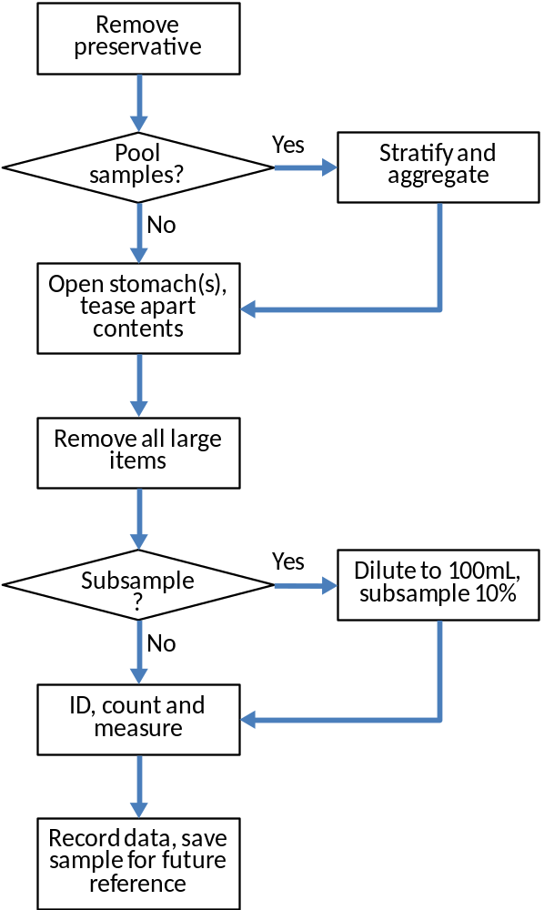

Figure 1. Work flow in fish diet analysis (Brett Johnson).

